Dear Spchna colleagues,

Welcome back! Our fall semester has started and is in full swing. Hearing from many, that it has been a busy start. I am always amazed by the epidemiologic outbreaks that arise in our day to day lives making our profession so very interesting.

Thanks to Suzanne Scott from the University of the Arts for the very well attended spring conference. It felt great to be in the city on a beautiful day and be greeted by musicians! The speakers were tremendous. Best of all was the ever present networking that happens informally at a table or over lunch.

And now we look forward to our winter conference which has been skillfully planned by Connie Murphy from University of Penn. The date is Jan 6, 2015 and the focus will be *wellness*. Expect to be filled with many new thoughts and practices to guide our college population towards a healthy life. See the Spchna web site for brochure .

Totally surprised to “win” the election the past spring, (easy to do when running unopposed!), I look forward to getting to know you better as I serve as president. Past experiences have shown me that the best way to grow is to serve with others. I am grateful to those who have been past presidents; most recently Robyn Spragins and those who continue to serve: Susan Fitzgerald (Cabrini) VP; Joanne Ocasio (Millersville) Secretary, Cheryl Donnelly (Swarthmore), treasurer and Robyn Spragins (West Chester) as member at large. As always, a hundred thanks to Chris Rooney who shares a wealth of knowledge and experience with the board and assists in teaching us how to obtain CEU’s . The board were generous with their time this past July to meet as a group for planning and orienting me. Thank you!

Mary Agnes Ostick, President

Mary Agnes Ostick

President SPCHNA

Future Conferences:

SPCHNA – University of the Arts – 5/20

ACHA – Orlando, Florida – 5/26-5/30

MCHNA – Shippensburg University – 6/3-6/5

MACHA – Atlantic City, NJ – 10/22-10/23

**Future Conferences in 2015**

Macha- October 22-23, 2015 Atlantic City NJ

**SPCHNA – January 6, 2016 University of Pennsylvania**

ACHA -May 31- June 4, 2016- San Francisco

Website: President: Mary Agnes Ostick 610-519-4070; [maryagnes.ostick@villanova.edu](mailto:maryagnes.ostick@villanova.edu) ; Vice President: Susan Fitzgerald 610-902-8400 [sfitzgerald@cabrini.edu](mailto:sfitzgerald@cabrini.edu); Secretary: Joanne Ocasio 717-872-3250 [joanne.ocasio@millersville.edu](mailto:joanne.ocasio@millersville.edu); Treasurer: Cheryl Donnelly, 610-328-8058 cdonnel1@swarthmore.edu; Member at Large: Robyn Spragins 610-430-4189 [RSpragins@wcupa.edu](mailto:RSpragins@wcupa.edu)

Fall 2015

Newsletter

October 29, 2013

Southeastern Pennsylvania College Health Nurses Association, Inc.

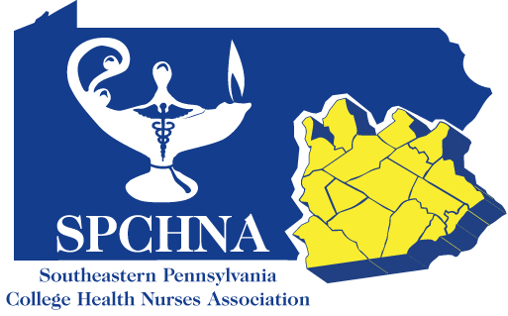

Log and Dialogue

*Renew your membership in SPCHNA by Jan 31, 2014 at www.spchna.org*